CUI

ATTENTION
Title of Document

Controlled by: insert the name of the DoD component if not otherwise identified in the letterhead
Controlled by: insert the name of the office creating the document and making the CUI determination
CUI Category: identify all types of CUI contained in the document
Distribution/Limited Dissemination Control: insert applicable distribution statement or LDC
POC: include the name and phone number or office mailbox for the originating DoD component or authorized CUI holder

ATTENTION
All individuals handling this information are required to protect it from unauthorized disclosure.

Handling, storage, reproduction, and disposition of the attached document(s) must be in accordance with 32 CFR Part 2002 and applicable agency policy.

Access to and dissemination of Controlled Unclassified Information shall be allowed as necessary and permissible to any individual(s), organization(s), or grouping(s) of users, provided such access or dissemination is consistent with or in furtherance of a Lawful Government Purpose and in a manner consistent with applicable law, regulations, and Government-wide policies.

Standard Form 901 (11-18)
Prescribed by GSA/ISOO | 32 CFR 2002

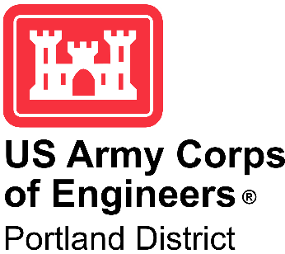
DESIGN DOCUMENT REPORT NO. XXX

THE DALLES LOCK & DAM
COLUMBIA RIVER BASIN
THE DALLES, OREGON

The Dalles AWS Backup Debris Management

DDR 50% Submittal
December 2024

EXECUTIVE SUMMARY

1. INTRODUCTION
The Dalles Lock and Dam project is a concrete gravity dam and embankment, spillway, powerhouse, and navigation lock run-of-the river type facility spanning the Columbia River approximately two miles east of the city of The Dalles, Oregon. One of the features of the facility is the East Fish Ladder (EFL) which provides for upstream fish passage past the dam. The EFL facility has both a main and auxiliary water supply; the backup Auxiliary Water Supply (AWS) will be required to operate as the additional AWS supply during the upcoming Fish Unit Rehabilitation Project which is expected to have a duration of two years and also when only one fish unit is being operated. To provide highly reliable and controlled flows, a more reliable debris management method to remove debris from the face of the trashrack located at the upstream face of the AWS Backup System piping is needed. The documentation of the main design criteria for the AWS Backup Debris Management system is the focus of this document.
2. PURPOSE
The purpose of The Dalles Auxiliary Water Supply (AWS) Backup Debris Management project is to provide an alternative and more reliable means for removing the debris from the trashracks at the intake of the East Fish Ladder AWS Backup System. Currently operations staff turn off the AWS Backup System and allow the river currents to remove debris from the screens. The original AWS supplies approximately 5,000 cubic feet per second (cfs) attraction water to the east, west, and south fish ladder entrances to attract upstream migrating adult fish into the fish ladder from the tailrace. The attraction water is currently supplied to the AWS by two “fish turbine” adjustable blade units located on the west end of the powerhouse. If one or both fish turbine units fail, water supplied to the AWS would be severely limited or eliminated. The East Fish Ladder AWS Backup System (AWSBS) was designed and constructed to provide an emergency backup supply of water to the auxiliary water supply (AWS) system. This Auxiliary Water Backup system was designed to provide a temporary (maximum 1 year) backup supply of water (approx. 1,400 – 1,600 cfs) to the AWS, when both fish turbine units fail, and the design AWS flow (approx. 5,000 cfs) is not available. (USACE, 2024)

The expected construction start date for Fish Unit Rehabilitation Project is late in the year 2032, per the current System Asset Plan (SAP). This project requires the AWS backup system to operate during that rehabilitation project to provide adequate flows for fish attraction. This was coordinated during Fish Unit Rehab Phase 1A. Fish Unit Rehab duration is currently scheduled as one year per unit for a total of two years. Flow tests have shown that the AWSBS trashracks have had periodic debris issues and require a more robust debris management strategy during the Fish Unit Rehab. Following Fish Unit Rehab, the backup AWS will be used if one or both of the new propeller Fish Units are forced out of service during adult fish passage season.
3. PROJECT LOCATION
The Dalles Lock and Dam is 192 miles upriver from the mouth of the Columbia River and two miles east of the city of The Dalles, OR. The Dalles Dam is the second dam upstream from the mouth of the Columbia River. The work area at the site itself is between the AWS Backup Intake trashrack precast concrete piers and the Service Gallery in which the FCQ7 Control Center and nearby PLC are located.
4. DESCRIPTION OF FACILITY
The AWS Backup system is comprised of, from upstream to downstream, an intake trashrack, a stoplog closure system, a 10’ diameter piping section with a butterfly valve, an assembly to bifurcate the flow into two – 7’ piping runs with butterfly valves, and an outlet into the penstock outfall.
5. CONSTRUCTION ACCESS
Access to the work area during construction will be from the asphalt and concrete travelway across the top of the embankment and structure for the East Fish Ladder. Access from the water is not anticipated except for the possibility of needing a rescue boat in the water during above water work.
6. CONSTRUCTION SCHEDULE
The expected construction start date for Fish Unit (FU) Rehabilitation Project is in the year 2032, per current System Asset Plan (SAP). The schedule for construction of the AWS Backup Debris Management system will need to be prior to the Fish Unit Rehabilitation and is assumed to be approximately 2 years. It is anticipated that equipment manufacturing and testing will consume the first 12 months beginning in late 2025. Any in-water work that may need to occur would be conducted within The Dalles winter maintenance period (between December and February) for adult fish facilities.
7. OPERATIONS DURING CONSTRUCTION
It is assumed that the AWS backup piping will not be in operation during installation of the proposed equipment. It is not anticipated that the proposed project would require any in-water diving work. A contractor may elect to perform some of the work from barges secured to the concrete pier and there also may be a need to have a rescue boat and personnel on the water during some or all of the construction activities.
8. COST
Construction costs for the proposed work have been estimated by USACE staff to be $xxx.xx. The preliminary estimated cost for the trashrake with brush head is appromately $1,400,000.The total project cost (design and construction) is estimated to be $yyyy.yy. The construction contract will take less than two years but could be impacted by potentially long lead times for equipment. If necessary, any in-water or on-water work would be completed during the allowable in-water work period.

CONTENTS

EXECUTIVE SUMMARY i
CONTENTS ii
APPENDICES xi
PERTINENT DATA xii
PREVIOUS REPORTS xiii
ACRONYMS xiv

SECTION 1 - Project Background 1-1
1.1 History 1-1
1.2 Project Description 1-2
1.3 Existing Conditions 1-3
1.4 AWS Intake OPerations 1-4
1.5 Main Project Features 1-5
1.5.1 Mechanical Brush 1-5
1.5.2 Structural 1-5
1.5.3 Electrical and Controls 1-5
1.5.4 Survey Datum & Control 1-5
1.5.5 Relevant Elevations 1-6
1.5.6 Trashrack Differential 1-6
1.6 References 1-7
1.6.1 General Project References 1-7
SECTION 2 - Biological Criteria 2-9
2.1 References and Standards 2-9
2.2 Species of Concern 2-9
2.3 In-Water Work Window 2-10
SECTION 3 - Hydraulic Analysis 3-1
3.1 Design Assumptions 3-1
3.2 Analysis Methods 3-1
3.3 Analysis Results 3-1
3.4 Design Recommendations 3-1
SECTION 4 - Civil Design 4-2
4.1 Design Assumptions 4-2
4.2 Design Criteria 4-2
4.3 Design Methods 4-2
4.4 Design Calculations 4-2
4.5 Design Recommendations 4-2
SECTION 5 - Environmental Design 5-3
SECTION 6 - Structural Design 6-1
6.1 Design Assumptions 6-1
6.2 Design Criteria 6-1
6.2.1 Material Properties 6-1
6.2.2 Loads 6-1
6.3 Design Methods 6-1
6.4 Design Calculations 6-2
6.5 Design Recommendations 6-2
SECTION 7 - Mechanical Design 7-3
7.1 Design Assumptions 7-3
7.2 Design Criteria 7-3
7.2.1 System Requirements 7-3
7.2.2 Machine Structural 7-4
7.2.3 Machine Mechanical 7-4
7.2.4 Machine Power 7-4
7.2.5 Control Systems 7-4
7.3 Design Methods 7-4
7.4 Design Calculations 7-4
7.5 Design Recommendations 7-4
SECTION 8 - Electrical Design 8-1
8.1 Design Assumptions 8-1
8.2 Design Criteria 8-1
8.2.1 480 VAC Service 8-1
8.2.2 Raceway 8-1
8.2.3 Wire and Cable 8-2
8.2.4 Instrumentation & Control System 8-2
8.3 Design Methods 8-2
8.3.1 480VAC Power Distribution 8-2
8.3.2 Raceway Routing 8-2
8.4 Design Calculations 8-2
8.5 Design Recommendations 8-2
SECTION 9 - Cultural Resources 9-1
SECTION 10 - Dam Safety 10-1
10.1 Design Assumptions 10-1
SECTION 11 - Construction 11-1
11.1 Environmental, Health, and Safety 11-1
11.2 Security 11-1
11.3 Basic Construction Assumptions 11-2
11.4 Construction Methodology 11-2
11.5 Design Methods 11-3
11.6 M&E Construction requirements to support facility connectivity 11-3
11.7 Commissioning of trash rake 11-3
SECTION 12 - Operations and Maintenance 12-1
12.1 Design Assumptions 12-1
12.2 Safety 12-1
12.3 Security 12-1
12.4 Operations 12-1
12.5 Maintenance 12-1
SECTION 13 - Cost and Value 13-1
13.1 Design Assumptions 13-1
13.2 Design Criteria 13-1
13.3 Design Methods 13-1
13.4 Design Calculations 13-1
13.5 Analysis Results 13-1
13.6 Design Decisions 13-1
13.7 Design Recommendations 13-1
SECTION 14 - Conclusions and Recommendations 14-1
14.1 Conclusions 14-1
14.2 Recommendations 14-1
SECTION 15 - References 15-1

TABLES

Table 1- AWS Trashrack Head Differential % Blockage Rating 1-6
Table 2- Flow-3D Numerical and Physical Options 3-3

FIGURES

Figure 1- The Dalles Dam Fish Ladder System (USACE, 2022) 1-1
Figure 2- AWS Backup System (USACE, 2019) 1-2
Figure 3- Trashrack Panel (USACE, 2015) 1-3
Figure 4- Bottom Panel Debris Matting (USACE, 2022) 1-3
Figure 5- Top Panel (USACE, 2022) 1-4
Figure 6 – Coarse Model Layout 3-1
Figure 7 – Fine Model Layout 3-3
Figure 8 – Coarse Model Surface Velocities 3-4
Figure 9 – Fine Model Surface Velocities 3-4
Figure 10 – Vertical Velocity Profile 3-5
Figure 11 – Electrical Loads (Atlas Polar) 7-5
Figure 12 - Single-Line Diagram 8-2
Figure 13 - East Exit Fish SCADA PLC 8-4
Figure 14- Brush System Control Panel Layout (Conceptual – Final Design Provided by Manufacturer) 8-4
Figure 15 – Load Flow Analysis 8-5

EQUATIONS

APPENDICES

APPENDIX A PLATES
APPENDIX B STRUCTURAL CALCULATIONS
APPENDIX C HYDRAULIC FIGURES
APPENDIX D MECHANICAL CALCULATIONS
APPENDIXE ELECTRICAL LOAD FLOW ANALYSIS
APPENDIX F VALUE ENGINEERING (VE) REPORT
APPENDIX G COST ESTIMATE AND SCHEDULE

PERTINENT DATA

PERTINENT PROJECT DATA
THE DALLES LOCK AND DAM - LAKE CELILO
GENERAL
Location | Columbia River, Oregon and Washington, River Mile 192
Drainage Area | Square miles | 237,001
RESERVOIR – LAKE CELILO (elevations referenced to 1929 datum 1947 adjustment)
Normal minimum pool elevation | Feet, msl | 155
Normal maximum pool elevation | Feet, msl | 160
Maximum pool elevation (PMF regulated, 2009) | Feet, msl | 178.4
Minimum tailwater elevation | Feet, msl | 76.4
Maximum tailwater elevation (PMF regulated, 2009) | Feet, msl | 127.2
Reservoir length (to John Day Dam) | Miles | 23.5
Reservoir surface area – normal maximum power pool (EL 160.0) | Acres | 9400
Storage capacity (EL. 160.0) | Acre-feet | 332,500
Power drawdown pool (EL. 155) | Acre-feet | 53,500
Length of shoreline at full pool (EL. 160.0) | Miles | 55
FLOOD CONDITIONS
Probable maximum flood (unregulated) | feet3/s | 2,660,000
Probable maximum flood (regulated) | feet3/s | 2,060,000
Standard project flood (unregulated) | feet3/s | 1,580,000
Standard project flood (regulated) | feet3/s | 840,000
100-year flood event (regulated) | feet3/s | 680,000
SPILLWAY
Type | Gate-Controlled Gravity Overflow
Length | Feet
Elevation of crest | Feet, msl
Number of gates | 23
Height (apron to spillway deck) | Feet | 130

PREVIOUS AND PLANNED REPORTS

Number | Title | Date
01 | The Dalles AWS Backup Debris Management EDR Final Report, Rev 1 | April, 2024
02 | TDA AWS System Operations & Maintenance Manual; USACE,2019 | March, 2019

ACRONYMS

Acronym | Description
AWS | Auxiliary Water Supply
AWSBS | Auxiliary Water Supply Backup System
DPS | Distinct Population Segment
EFH | Essential Fish Habitat
EFL | East Fish Ladder
EL | Elevation Level
ESA | Endangered Species Act
ESU | Evolutionary Significant Unit
FU | Fish Unit
NEPA | National Environmental Protection Act
NMFS | National Marine Fisheries Service
NRHP | National Register of Historic Places
OOS | Out of Service
PDT | Product Development Team
ROV | Remote Operated Vehicle
USACE | United States Army Corps of Engineers
USFWS | United States Fish and Wildlife Service

Project Background

History
The Dalles Lock & Dam is 192 miles from the mouth of the Columbia River near the city of The Dalles, Oregon. The dam is a concrete gravity and embankment structure that was constructed by U.S. Army Corps of Engineers (operationally administered by the Portland District) in the 1950s for the purposes of hydroelectric power generation and maintenance of a navigational pool (Lake Celilo). The construction of the dam also included northern and eastern fish ladders for the passage of fish within the Columbia basin to upstream spawning grounds. The East Fish Ladder (EFL) is the primary and most heavily used of the two systems; likely due to its location within the historical riverbed and the attraction flows produced by the powerhouse.
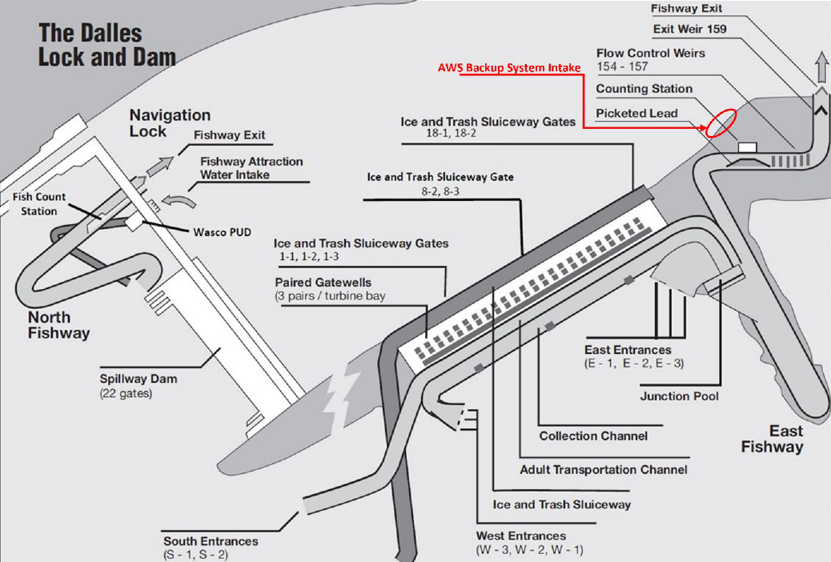

Figure 1- The Dalles Dam Fish Ladder System (USACE, 2022)

The EFL is a pool and weir ladder located at the eastern extension of the powerhouse providing passage for Salmon, Steelhead, and several listed species of the Endangered Species Act (ESA). A key aspect of the ladder functionality is the attraction flow at the inlet; which in the case of the EFL is normally provided attraction flow units (approx. 5,000 cfs, ea.). An Auxiliary Water System (AWS) was completed in 2020 that addressed risk profiles that had been studied since 2008 to provide an alternative source of attraction flow in the event that the turbine units failed (original to construction of the project). The AWS is an auxiliary water source for the east, west, and south entrances of the EFL, consisting of a forebay inlet structures w/ protective trashracks, 10-ft diameter penstock through the eastern non-overflow concrete dam, 120-inch isolation and emergency shutoff valve, bifurcation to 7-ft diameter conduits, 84-Inch diameter on/off control valves, and interconnection with the attraction flow system.
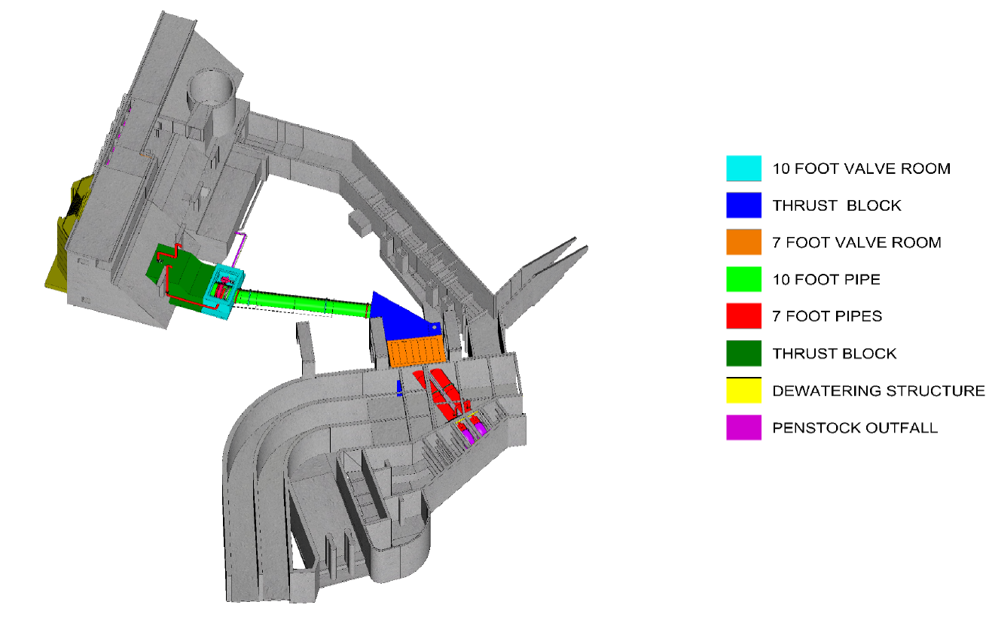

Figure 2- AWS Backup System (USACE, 2019)

Project Description
The AWS intake is protected by protective trashracks that are installed into a slot within the forebay intake structure that was added as part of the AWS Backup System in 2020. The inlet trashrack is comprised of eleven (11) identical 6-ft H x 24-ft W panels which can be stacked in any order to isolate the intake from debris and fish using screening W15-W-2, 1-1/4” x 3/16” steel bar grating secured to the steel frame of the trashrack.
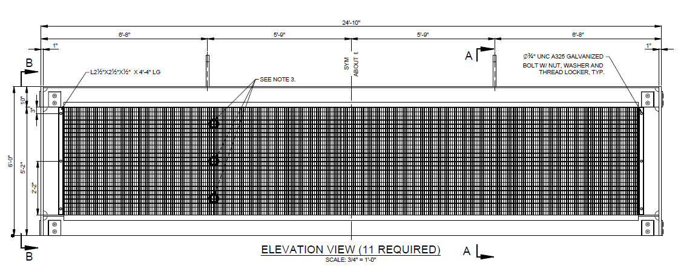

Figure 3- Trashrack Panel (USACE, 2015)
The main goal of this Project is to provide a mechanical method for dislodging debris from the trashracks at the EFL AWS Backup System intake. Currently, operations staff must shut down the AWS backup system to let river currents clear accumulated debris from the screens. An alternatives analysis as documented in the USACE report entitled “The Dalles AWS Backup Debris Management EDR Final Report, Rev 1” dated April of 2024 resulted in the determination to proceed with Alternative 11 (dedicated mechanical rotating brush), along with Alternative ME-1 (level sensors).

Existing Conditions
The AWS intake is protected by 1-1/4” square bar grating which is affixed uniformly to eleven (11) structural panels. The bar grating screens debris suspended in the river flow. The debris is primarily aquatic grasses, but some small diameter woody twigs or leaves carried by the river may be present. There is little to no non-organic material that has been known to collect on the intake.
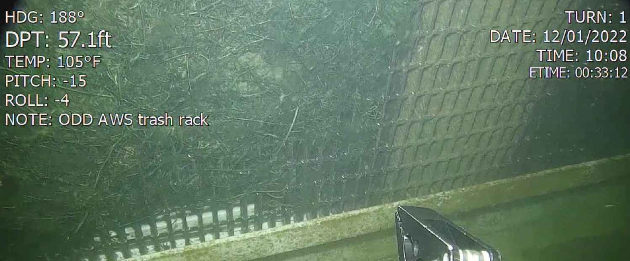
Figure 4- Bottom Panel Debris Matting (USACE, 2022)

The debris matting was surveyed with a Remote Operated Vehicle (ROV) by USACE in 2022 which noted instances of material collections which constitute a blockage matt; but conditions ranged from clean to fully blocked. The matting of rack bars was variable with the depth and the right side (when observed from the lake side of the screens) had more debris collected. Rack bars near the water surface had lower buildups noted but did exhibit impingement of aquatic grasses pinched between the bar grating and L brackets.
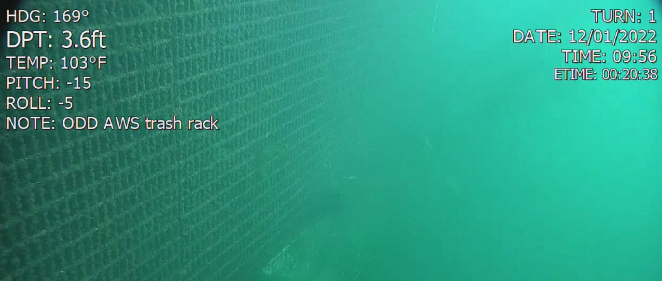
Figure 5- Top Panel (USACE, 2022)

AWS Intake OPerations
The AWS intake is intended to provide supplemental attraction flow when a single operational fish turbine unit is in service or to replace the flows of both fish turbine units in case that both units fail or are removed from service. The nominal flows of both fish turbine units is 5,000 cfs system. The AWS intake provides 1,400 to 1,600 cfs of flow for the east entrance only (if both units are offline) when operating alone or as a combined flow totaling 4,000 cfs for two entrances when operating with a single fish turbine unit. Supplemental operation with both fish turbine units is not an operational condition. The performance of the AWS intake is crucial to achieving the flows required when both turbine units are offline (extended outages are anticipated in order to refurbish the units).
Operation of the AWS intake requires a full penstock and the motorized operation of the 7-ft dia conduit valves, 10-ft penstock valves, proper setting of vent/purge valves, and the correct scheme of entrance weirs to be enacted (refer to TDA AWS System Operations & Maintenance Manual; USACE,2019). Generally, the current system is shut down for passive cleaning when the differential across the trashracks reaches 2-ft (difference between forebay headwaters and intake water surface just behind the trashracks). A maximum of a 4-ft differential was noted after 2.5 weeks of continuous operation in February 2019; resulting in 2x daily differential checks and ROV inspection after prolonged operation.

Main Project Features
The intake trashrack cleaning system will be comprised of the following major systems/components:

Mechanical Brush
A rotating durable synthetic brush will be used to clear debris from the submerged screens of the AWS intake. The brush will be positioned and powered using a telescoping mechanical boom arm affixed to a trolley chassis traveling on a deck mounted track at EL 185.0. The brush is positioned and indexed over the entire rack surface using the telescoping, slewing, and traveling motions of the equipment. The mechanical equipment is primarily welded steel boxed frame structural fabrications whose movements are internally powered.

Structural
The AWS Backup System intake is not part of the original dam and was installed in 2020 using precast reinforced modular concrete piers that sit on an underwater foundation slab and that are passively anchored to the original structure. The project will install equipment on the forebay deck of the AWS Backup System intake using post installed chemical anchors. Underwater construction is not expected. The existing handrails will be modified to provide equipment clearance and protection.

Electrical and Controls
Electrical supply to the equipment will be from a 480V 3φ Motor Control Center (MCC) FCQ7 in the dam service gallery near the AWS intake at EL 168.0. The equipment controls will be internal and provide automatic or manual operation of the cleaning brush over the entire intake surface. External level sensors across the AWS trashracks will be added to provide feedback to both the brush controls and the external plant controls about the differential across the trashracks for planning cleaning operations, and tie into the Fish SCADA system by using the existing PLC cabinet located in the service galley near MCC FCQ7..

Survey Datum & Control
Project Datum:
- Horizontal – Oregon Coordinate Reference System, Columbia River East, North American Vertical Datum of 1983, adjustment of 2011, Geoid 12B
- Vertical – National Geodetic Vertical Datum of 1929 (NGVD29)
Project Survey Control:
- Project survey control information was provided by the USACE and is included on the contract drawings.

Relevant Elevations
A summary of the relevant elevations and design features for the AWS Intake are listed below:
Water Surface Elevations (WSE)
- Minimum WSE Forebay El. 155.0
- Maximum WSE Forebay El. 160.0
- Forebay WSE Normal Range El. 157.0 – El. 159.5
Structural Elevations
- Forebay Deck El. 185.0
- Trashrack Invert El. 104.0
- Penstock CL El. 116.5
- Top of Trashracks El. 170.0

Trashrack Differential
The maximum allowable differential across a trashrack is 5-ft which conforms to the requirements of EM-1110-2-2400 - Structural Design and Evaluation of Outlet Works, which corresponds to an 83% blockage per the blockage rating table provided in the AWS Debris Management Engineering Design Report (EDR) per the table below:
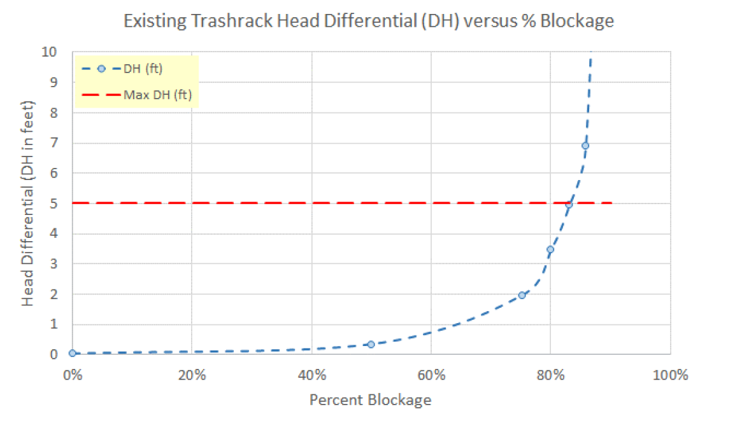
Table 1- AWS Trashrack Head Differential % Blockage Rating

References

General Project References
- Records & Studies
  - TDA AWS Intake Record Drawings; USACE,2020
  - TDA AWS Intake O&M Manual; USACE, 2019
  - TDA AWS Debris Management EDR; USACE, 2024
  - TDA Record Drawings; USACE
- USACE ER
  - ER 5-1-14 USACE Quality Management System
  - ER 415-1-10: Contractor Submittal Procedures
  - ER 1110-1-12: Quality Management
  - ER 1110-1-8155: Specifications
  - ER 1110-1-8159: Engineering and Design-DRCHECKS
  - ER 1110-2-1150: Engineering and Design for Civil Works Projects
  - ER 1165-2-217: Civil Works Review Policy
- State of Oregon
  - State of Oregon Specialty Code(s)
- USACE EM
  - EM 385-1-1: Safety and Occupational Health (SOH) Requirements
  - EM 1110-2-2000: Standard Practice for Concrete for Civil Works Structures.
  - EM 1110-2-2400: Structural Design and Evaluation of Outlet Works
  - EM 1110-2-1424: Lubricants and Hydraulic Fluids, 2016
  - EM 1110-2-2610: Mechanical and Electrical Design for Lock and Dam Operating Equipment, 2013
- American Welding Society (AWS)
  - AWS D1.1-2020: American Welding Society, Structural Welding Code - Steel
  - AWS D1.6-2017: American Welding Society, Structural Welding Code – Stainless Steel
- American Institute of Steel Construction (AISC)
  - AISC: Manual of Steel Construction (15th edition)
  - AISC 360-16: Specification for Structural Steel Buildings
- American Society of Civil Engineers (ASCE)
  - ASCE 7-22: Minimum Design Loads and Associated Criteria for Buildings and Other Structures
- National Fire Protection Association (NFPA)
  - NFPA 30: Flammable and Combustible Liquids Code (2021)
  - NFPA 70: National Electrical Code (2020)

Biological Criteria

Background
The EFL provides for upstream fish passage past the dam via both a main water supply and an AWS, which supply attraction water to migrating fish. The AWS will be used during upcoming Fish Unit Rehabilitation Project (expected duration of two years), when one of the two fish turbines are taken out of operation during annual maintenance (December through February), or if one or both of the fish turbines were to fail. The proposed debris management system on the upstream face of the AWS Backup System Piping is needed to clear debris from the trashrack, which will allow for reliable and controlled flows in the AWS to facilitate successful fish passage.

References and Standards
Installation of the debris management equipment will be conducted in accordance with existing requirements guiding protection of salmonids, including the following:
- NMFS (2020). Endangered Species Act Section 7(a)(2) Biological Opinion and Magnuson-Stevens Fishery Conservation and Management Act Essential Fish Habitat Response for the Continued Operation and Maintenance of the Columbia River System.
- USACE (2024). 2024 Fish Passage Plan Lower Columbia & Lower Snake River Hydropower Projects March 2024 – February 2025. Chapter 3, The Dalles Dam.
- USACE (undated). Approved work windows for fish protection for waters within National Park boundaries, Columbia River, Snake River, and Lakes by watercourse
- USFWS (2020). Endangered Species Act - Section 7 Consultation Biological Opinion. Columbia River System Operations and Maintenance of 14 Federal Dams and Reservoirs Washington, Oregon, Idaho, and Montana. U.S. Fish and Wildlife Service Reference: 01EWFW00-2017-F-1650 July 24, 2020
- USFWS (2008). Biological opinion on the continued operation and maintenance of the Willamette River Basin Project and effects to Oregon chub, bull trout, and bull trout critical habitat Designated under the Endangered Species Act. U.S. Fish and Wildlife Service, Oregon Fish and Wildlife Office. July 11, 2008.

Species of Concern
Federally listed salmonids under the jurisdiction of NMFS occur in the vicinity and migrate beyond The Dalles Dam. These include:
- Snake River Fall Chinook Salmon evolutionary significant unit (ESU) (Oncorhynchus tshawytscha)
- Snake River spring/summer Chinook salmon ESU (O. tshawytscha)
- Upper Columbia River spring Chinook salmon ESU (O. tshawytscha)
- Lower Columbia River Coho Salmon (O. kisutch)
- Snake River sockeye salmon ESU (O. nerka)
- Snake River Steelhead distinct population segment (DPS) (O. mykiss)
- Upper Columbia River Steelhead DPS (O. mykiss)
- Middle Columbia River steelhead DPS (O. mykiss)
Upstream migrants are present at the dam year-round, whereas downstream migrating juvenile salmonids and shad are present primarily from April through November. The federally listed bull trout (Salvelinus confluentus), which is under the jurisdiction of USFWS, has also been periodically documented in the vicinity of the fish ladders, as well as Pacific lamprey (Entosphenus tridentatus). Adult peak passage timing is summarized in Table 2 below.
Table 2. The Dalles Dam Adult Fish Peak Passage Timing (based on yearly counts since 1957, except lamprey since 2000)
Species | Peak Period
Spring Chinook | April 13 – May 23
Summer Chinook | June 6 – August 1
Fall Chinook | September 2 – September 23
Sockeye | June 20 – July 10
Steelhead | July 9 – September 23
Coho | September 3 – October 25
Lamprey | June 29 – August 1
Source: USACE 2024, Table TDA-3.

All work would be conducted in accordance with the Fish Passage Plan, which outlines measures for fish passage and protection. However, it is assumed that dewatering will not be required for installation of the debris management system and no in-water work would be required. Therefore, there would be no effect to listed or sensitive fish species as a result of the implementation of the proposed project.

Criteria
The depth (40-45 feet) of the AWS backup system minimizes entrainment potential of listed juvenile salmon. Because of this, and because the location in the forebay is much less likely to entrain juvenile salmon, NMFS did not require juvenile fish screen criteria to be enforced at the intake during development of the AWSBS DDR in 2014. The existing 0.75” trashrack clear spacing is being carried forward as a design criterion for maximum clear spacing for alternatives in this EDR (USACE 2024 [EDR Final Report, Rev1]).
Criteria Specifications:
Trashrack Flow Rates
a. Minimum design flow rate per DDR (USACE 2021 Draft) = 1400 cfs.
b. Estimated range of operating discharge through trashrack:
1440 – 1600 cfs
c. Flow changes resulting from modifications:
- System flow rates shall not be reduced by more than 10 cfs.
- This flow restriction translates to an added headloss of 1 foot.
  - This represents a limit in the increase in the systemic headloss as the result of modifications to the trashrack, added piping and/or porosity plate; and/or any new upstream structure.
- The 10 cfs flow reduction limit is based on the following assumptions: o Minimum forebay = 155 ft NGVD 29
  - Maximum design AWS conduit Water level = 89.5 feet
  - System design head loss coefficients increased by 5%
  - Computed AWS discharge = 1410 cfs.
  - Minimum AWS discharge per criteria = 1400 cfs
  - Net difference: 10 cfs.

- Any proposed modifications should not cause an increase the intake velocities at or near the surface. (Increased surface velocities could entrain juvenile fish.)
Trashrack approach velocities:
a. Average over intake opening: 1.2 – 1.3 ft/s
b. Average through screen openings: 1.7 – 1.9 ft/s
c. Estimated local maximum near Intake: 2.5 – 4.5 ft/s
(1) At approximately 40 feet depth
The original TDA AWS BS DDR (USACE draft 2021) identified risks as low given more than 80% of the juvenile fish are distributed within the upper 30 feet of the water column. Adult salmon and lamprey were not expected and have not been observed to be impinged upon the trashrack, given the intake is located downstream (approximately 65 feet) and deeper (more than 30 feet) the fish ladder exit to the forebay.

In-Water Work Window
While not anticipated, any in-water work would be conducted within The Dalles winter maintenance period (between December and February) for adult fish facilities, which includes the auxiliary water supply, as described in the 2024 Fish Passage Plan.
Summary of operations at TDA (East Ladder Entrance gate configurations and operations under AWSBS operation during FU rehabilitation (single FU OOS), and AWSBS operations during double FU OOS, and any potential impacts to fish ladder or LPS operations during AWSBS cleaning cycle).
Construction and operations implications for adult salmonids and lamprey passage
Design and construction implications for fish in the near field forebay (adult fish exiting east fish ladder)

Hydraulic Analysis
The AWS Intake is situated within the EFL forebay within the eastern non-overflow dam embankment groin and may be subject to unusual turbulence or currents due to the proximity of adjacent features and the prevailing flows within the waterway.

Design Assumptions
The concept of a mechanical brush which dislodges impinged debris from the trashracks, but does not remove the debris from the waterway, relies heavily on the assumption that a swift enough current exists to carry the dislodged debris away from the intake. The design also predominantly relies on the assumption that the AWS intake is shut down during bushing cycles so that the dislodged debris will not relodge itself immediately after brushing due to the operational intake flow velocities.

Analysis Methods
A Computational Fluid Dynamics (CFD) model was developed to predict flow velocities along the face of the intake screen and based on the waterway bathymetry, geometry of existing structures, and waterway flow data to confirm the basic design assumptions that flow velocities are sufficient to carry raked debris away from the intake and used to estimate loads on the proposed trashrake with brush head system.

The computer program Flow-3D was used for the analysis and is an industry standard for solving free surface flow problems Figure 6 shows the extent of the coarse model. The model extends 8,500 ft upstream of the spillway. The bathymetry used was obtained from the USACE from their survey done in 1999.
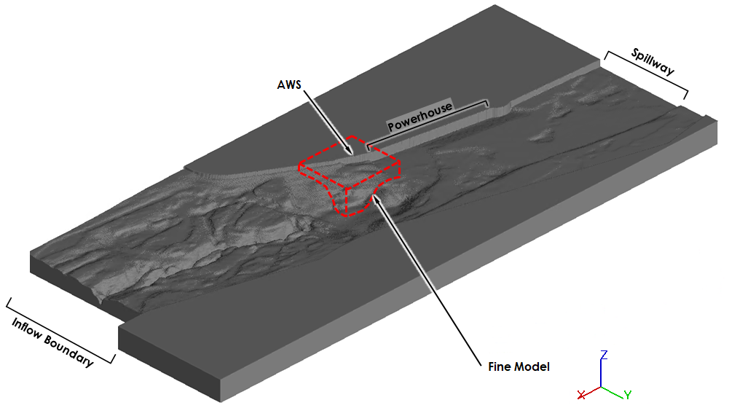
Figure 6 – Coarse Model Layout

The Flow-3D model was run under a one-fluid, free-surface flow condition utilizing the gravity and viscosity/turbulence options available within Flow-3D. This is the methodology recommended by Flow Science for these types of problems. Key numerical options used in this analysis are described in Table 2.

Parameter | Description
Turbulence | Turbulence utilized the implicit renormalized group theory (RNG) κ-ε model. The RNG κ-ε model is similar to the standard two-equation κ-ε model and is the turbulence model recommended for most hydraulic applications.
Pressure | Pressure calculations were made using the generalized minimum residual implicit pressure-velocity solver and the dynamically adjusted pressure convergence tolerance setting available within Flow-3D. This pressure solver setup is the default setting in Flow-3D and is recommended for most hydraulic applications.
Momentum Advection | A second-order momentum advection option was used for all simulations. The second-order option was adopted for this analysis as it has been found to best capture the secondary, swirling flows and eddies that will be present/generated within the existing and proposed conveyance systems.
Meshing | The CFD modeling approach utilized Cartesian (i.e., x-, y-, z-) coordinates. The minimum mesh dimensions used in the analysis were 20 feet. Number of active cells was about 2,600,000.
Table 2- Flow-3D Numerical and Physical Options
At the upstream boundary the total desired river flow was input. At the location of the powerhouse a “sink” was input to the model that would draw off the desired powerhouse flow over the area of the intakes. At the spillway an outflow boundary was used with a prescribed water level. This mimics the operation of a gated spillway that maintains the selected water level and passes out of the model the difference in flow between the river flow and the powerhouse flow.
A second model, using a finer mesh resolution, was developed that focused on the area around the AWS intake. Figure 7 shows the extent of the model relative to the intake location.
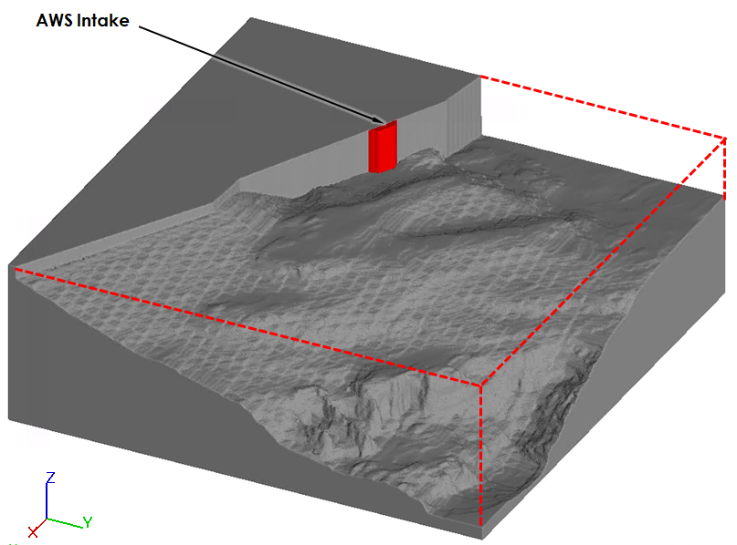
Figure 7 – Fine Model Layout

The model is 880 ft square. Two meshes are used, a 2-ft mesh covering the whole model and a smaller mesh with 1-ft cells closer to the intake. The other model parameters listed in Table 1 were the same in both models. The boundary conditions for this smaller model are taken directly from the results obtained in the coarse model using a “grid overlay.” A snapshot of the velocities on each face are taken from the coarse model and used as the boundary for the fine model.

Analysis Results
The model was run at a 100-yr river flow of 680,000 cfs. The powerhouse was discharging 375,000 cfs, with the remaining 305,000 cfs going through the spillway. Figure 8 shows a plot of the surface velocities for this case. The velocity varies considerably in the river channel with higher velocities generally corresponding to the deeper areas and lower velocities in the shallow areas.

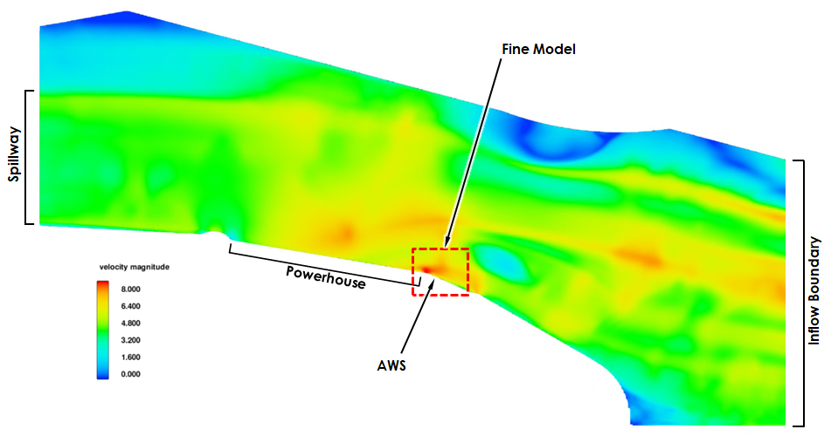

Figure 8 – Coarse Model Surface Velocities
Figure 9 shows a color map of the velocities in front of the ASW intake. The section is taken at El. 130 – about 30 ft below the water surface. The peak velocity is about 8 ft/sec at the flow concentration at the upstream corner of the intake but generally lower along the face of the trashrack. A series of similar plots at vertical 10-ft intervals from El. 110 to El 160 is shown in Appendix C.
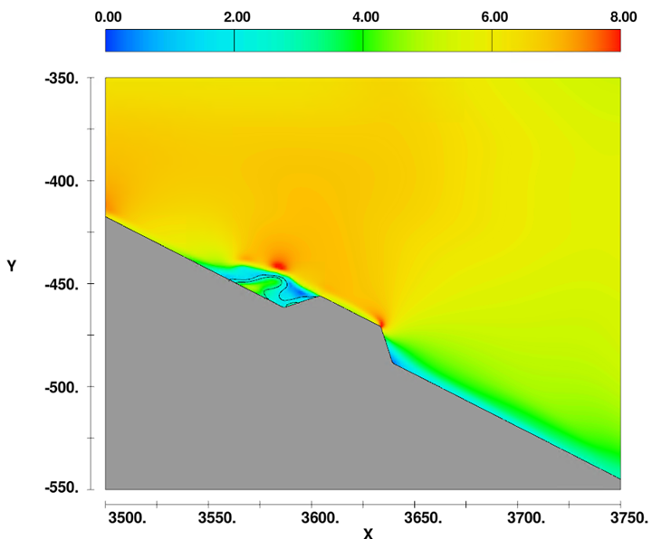
Figure 9 – Fine Model Surface Velocities

Figure 10 shows a plot of the vertical profile of the velocity magnitude. The transect is taken at the center of the rack 1.5 ft from the face. The maximum velocity is about 5.5 ft/sec.
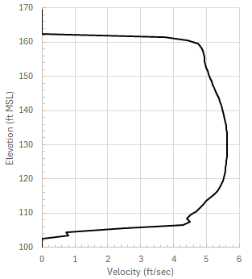

Figure 10 – Vertical Velocity Profile

Design Recommendations
The analysis confirmed that the velocities are swift enough to carry away dislodged debris but that under maximum flows the trashrake equipment must be supplied to accommodate 5.5 ft/s drag forces. It is expected that operation of the rake would not occur at maximum river flows, but the maximum conditions will be coordinated with the requirements of the rake.

Civil Design
The proposed project will have little work that has typically been associated with civil design. In order to route electrical and control wiring from the service gallery to the trashbrush and associated devices, three conduits (two at 1-1/2” and one at 1”) will need to be installed in two relatively short lengths of vegetated areas and across the asphalt roadway atop the embankment off the end of the dam. The amount of asphalt to be removed and replaced will be minimal (less than 10 square yards). The intent will be to restore the pavement with three inches of asphalt over eight inches of aggregate base material or to match the existing asphalt and aggregate thicknesses, whichever is greater. The asphalt and aggregate materials and installation will be to Oregon Department of Transportation (ODOT) standards. Trenching in excavated areas will be backfilled with the removed materials and seeded using a locally sourced, readily available grass seed mix.

Environmental Design
USACE supports ecosystem sustainability as a mission focus for all project development and land management decisions. This focus reflects protection of our natural resources under numerous federal laws, including the National Environmental Protection Act (NEPA), Clean Water Act, Coastal Zone Management Act, Endangered Species Act, Fish and Wildlife Coordination Act, Magnuson Fishery Conservation and Management Act, Migratory Bird Treaty Act and many more. (USACE, 2021)
Because the proposed AWS backup debris management work has a minimal footprint within the existing facility and is not ground disturbing, the following regulatory requirements will not require additional evaluation of documentation. USACE (2019) made these determinations based on findings summarized below:
- National Environmental Policy Act (NEPA) - USACE determined that the proposed action qualifies as a categorical exclusion as described by USACE’s regulations for implementing NEPA, 33 CFR Part 230. This action can be excluded from further NEPA documentation.
- Bald and Golden Eagle Protection Act - There is no potential for impact to preferred nesting, rearing, or foraging habitat, and no potential for a ‘take’ of bald or golden eagles.
- Clean Air Act - Any equipment used during construction will be required to meet State emission standards, with all emissions being temporary and localized.
- Clean Water Act - Proposed work will not cause discharge of fill or polluted material into Water of the United States.
- Coastal Zone Management Act - The project is not located within Oregon or Washington Coastal Zones.
- Federal Endangered Species Act - The proposed action will not occur in water or change the flow of water and there will be no effect to salmonids. (see Section 2)
- Magnuson-Stevens Fishery Conservation and Management Act – Essential Fish Habitat (EFH) for coho salmon and Chinook salmon occurs in the Columbia River. The proposed action will not affect any EFH or the habitat of prey base(s) because no in-water will occur and there be no change to water flow.
- Marine Mammal Protection Action - The project will not take place in-water and will therefore not affect marine mammals or marine mammal habitats.
- Marine Protection, Research, and Sanctuaries Act - The proposed action does not require disposal of materials into the ocean.
- Migratory Bird Treaty Act - The proposed action will not result in the take (including killing, capturing, selling, trading, and transport) of any migratory birds.
- National Historic Preservation Act – USACE determined that the work will have No Effect on any historic properties and/or other cultural resources and will have No Effect on The Dalles Dam’s NRHP eligibility. (see Section 12)
- Rivers and Harbors Act - The Columbia River is subject to Section 10 of the Rivers and Harbors Act, which addresses navigability in Waters of the United States. The proposed action will not create any barriers to navigation and is in compliance with the Act.

Structural Design
The project intends to add mechanical equipment to the AWS intake for rotating brush cleaning of the submerged trashracks. The equipment will be anchored to the EL 185.0 deck of the precast reinforced modular concrete piers using post installed chemical anchors. Handrails will be modified to accommodate the equipment clearances and operator safety.

Design Assumptions
The structural design will include post installed chemical anchors, replacement handrails, misc. equipment baseplates/leveling grout. Structural deficiencies, improvements, or repairs to the concrete structure of the AWS intake are not expected. Relevant data sources including project records and major assumptions will be listed as the project design develops.

Design Criteria
The structural design is expected to include chemical anchors, structural steel, and grout.

Material Properties
Relevant material information will be listed as the project design develops based on ASTM/ANSI Standards.

Loads
Relevant loads in accordance with ASCE 7-22 and coordination with the mechanical equipment will be included in the structural design.

Design Methods

Concrete & Grout
Reinforced concrete and grout designs will be in accordance with the methods and requirements of ACI-318(22), Oregon Specialty Structural Code, and applicable provisions of EM 1110-2-2400.

Structural Steel
Structural steel features shall be designed in accordance with AISC 360-22, Specifications for Steel Buildings using the LFRD methodology, Oregon Specialty Structural Code, and applicable provisions of EM 1110-2-2400; utilizing SAP 2000 design tools.

Post-Installed Anchors
Post-Installed chemical anchors will be designed in accordance with the methods and requirements of ACI-318(22); utilizing Hilti Profis Engineering Suite.

Handrails
Replacement handrails or modifications will be supplier designed in accordance with the requirements of OSHA 1910.29.

Design Calculations
The calculations associated with the design methodology will be summarized.

Design Recommendations
Details of the as-designed features and relevant coordination points with related project scope will be summarized.

Mechanical Design
The project mechanical equipment will be provided for brushing the existing submerged trashracks. The brushing machine will be based on a powered rotating brush head to dislodge impinged debris on AWS Intake trashracks; with the brush positioned and powered using a telescoping mechanical boom arm affixed to a trolley chassis traveling on a deck mounted track at EL 185.0. The brush is positioned and indexed over the entire rack surface using the hydraulically or electrically powered telescoping, slewing, and traveling motions of the equipment.

Design Assumptions
The mechanical equipment design will be a modification of a standard product line for a large water intake cleaning system. Relevant data sources including project records and major assumptions will be listed as the project design develops.

Design Criteria
The mechanical design of the equipment will be based on a standard product line and is expected to include the structural design of the equipment components/frames, mechanical design of rotational components, design of hydraulic fluid and/or electrical power systems, and the design of the machine control systems; all of which will detailed by the product manufacturer.

System Requirements
A summary of the design criteria for the mechanical brush are listed below:
- Equipment Location El. 185.0; AWS Intake Forebay
- Maximum Operational Depth EL 104.0
- Trashrack Size 23-ft W (clear) x 66-ft H
- Trashrack Details Vertical; 1-1/4” x 3/16” steel bar grating
- Normal Brush Force 100-lbs (min)
- Brush Width 5-ft (approx.)
- Brush Power Hydraulic
- Telescoping Boom Power Hydraulic
- Boom Slewing Power Hydraulic
- Trolley Travel Power Electric

Machine Structural
The structural fabrications will be primary welded (or bolted) boxed fabrications from ASTM A36, ASTM A 572 (gr 50), or ASTM 500 (HSS shapes); stresses will be code allowable or 60% (36% shear) of the yield points of the materials involved. Fabrications will be painted with a marine-grade hi-solids epoxy coating system.

Machine Mechanical
Details and minimum requirements of the mechanical components including shafts, pins, wheels, gears, bearings, and other mechanical components will be developed.

Machine Power
The power will be supplied by a 480V (AC) 3-phase electrical supply which powers electric motors for the electrical motors and hydraulic fluid power systems. Hydraulic systems will utilize Environmentally Acceptable Lubricants (EAL) in accordance with the EAL provisions of EM 1110-2-1424; Lubricants and Hydraulic Fluids, 2016.

Control Systems
The controls will be a PLC based systems which controls the mechanical movements and interlocks of the raking system. Details and minimum requirements of control system and logic will be developed.

Design Methods
The design of machine systems is based on a standard product line which has been developed in accordance with relevant design principles and guidance from AISC, ASME, and EM 1110-2-2610: Mechanical and Electrical Design for Lock and Dam Operating Equipment, 2013.

Design Calculations
Design calculations will be summarized with deference to the brushing machine designs performed by the manufacturer.

Recommendations
Additional details of the- as designed features and relevant coordination points with related project scope will be summarized as design develops. It is recommended to base the mechanical design of the mechanical brushing machine around the Atlas Polar- Model DT9300 trashrake as modified for use in this application, as discussed in Section 14- Conclusions & Recommendations. The proposed equipment has the following nominal electrical loads:
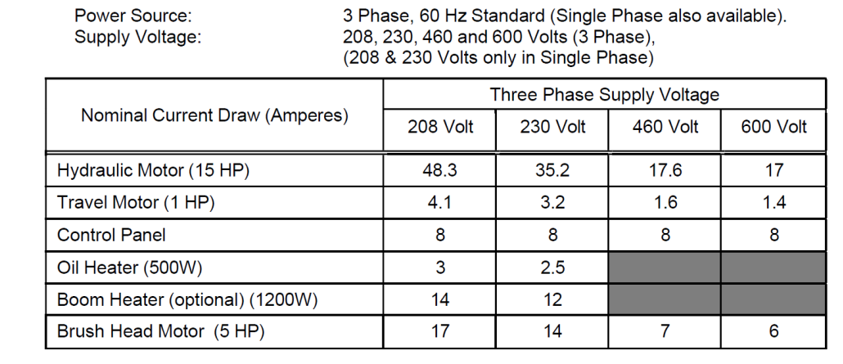
Figure 11 – Electrical Loads (Atlas Polar)

Electrical Design
The provision of electrical power to the AWS Intake forebay deck and interconnection of the remote provisions of the brushing machine controls with the EFL/Plant Control SCADA systems will be provided for mechanical brush operation.

Design Assumptions
The following assumptions have been made with regards to the design of the debris management equipment.
- The power supply for the cleaning brush will be from the existing Motor Control Center (MCC) FCQ7.
- The new cleaning brush will be rated for 480VAC, and the maximum nominal current draw is approximately 32.4A.
- Existing PLC cabinet has sufficient I/O points as spare for interface between the existing Fish SCADA system and the field devices.

Design Criteria
The electrical and controls design includes electrical power supply to the bushing machinery and control feedback to the EFL SCADA.

480 VAC Service
The power distribution system will be rated 480 VAC, 3-phase and will provide service to the cleaning brush equipment. The existing MCC FCQ7 is in the service gallery near east fish ladder exit at EL. 168 and will be utilized for supplying power to the cleaning brush equipment. Design consideration include the following:
- Electrical termination and distribution equipment required for distribution of the power supply including raceways and cables.
- Expansion of existing MCC FCQ7 for circuit availability
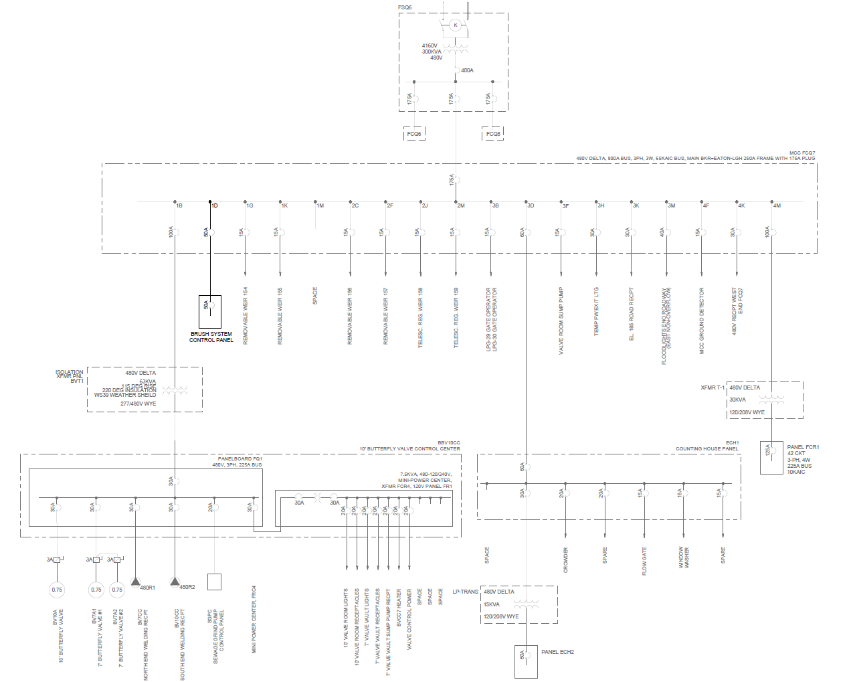
Figure 12 - Single-Line Diagram

Raceway

Rigid galvanized steel (RGS) & Polyvinyl chloride (PVC) schedule 80 conduit will be used for distributing the 480 VAC cables and the control and monitoring system cabling. RGS conduit will be used for all raceways above ground. PVC schedule 80 will be used for raceways below ground.

Wire and Cable
Exposed low voltage power and control cable will be low-smoke zero-halogen (LSZH) jacked multi-conductor cable. The power and control cable will include the following features:
- The power supply for the cleaning brush will be from the existing Motor Control Center (MCC) FCQ7.
- Class B copper conductors
- Cross-Linked Polyethylene (XLP) insulation (XHHW-2)
- Class B grounding conductor
- Flame retardant low-smoke zero-halogen (LSZH) overall jacket
- 90°C temperature rating
- 600-volt rating

Instrumentation & Control System
Two ultrasonic level sensors will be installed and measure the water surface levels and differential water level across the AWSBS trashrack in the form of two 4-20mA signals. The level sensors will be located on the upstream and downstream faces of the trashrack and tie into the Fish SCADA system by using the existing PLC cabinet located in the service galley near MCC FCQ7. A comparison of the 4-20mA level signals will be done at the East Exit Fish SCADA PLC and if they are outside a specified threshold, indication pilot lights ‘AWS BACKUP INTAKE WATER LEVEL DIFF. HIGH’ at the East Exit Fish SCADA PLC and the Brush System Control Panel will illuminate. Additionally, indication pilot lights ‘AWS BACKUP INTAKE BRUSH IN OPERATION’ and ‘AWS BACKUP INTAKE BRUSH TROUBLE ALARM’ will be installed and utilized at both the East Exit Fish SCADA PLC and Brush System Control Panel.
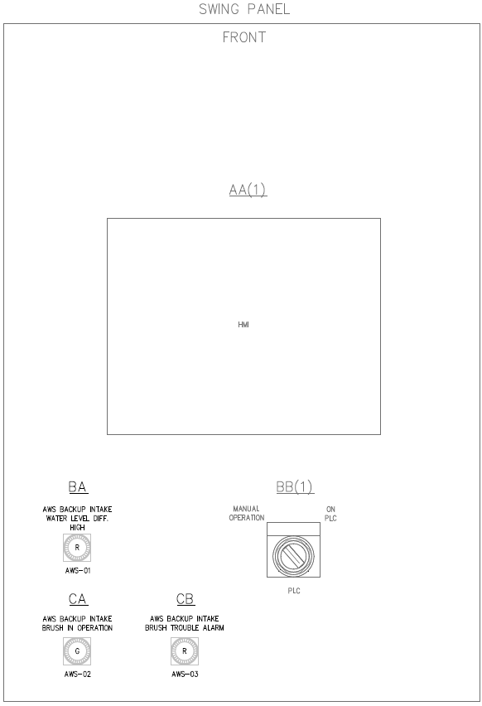
Figure 13 - East Exit Fish SCADA PLC
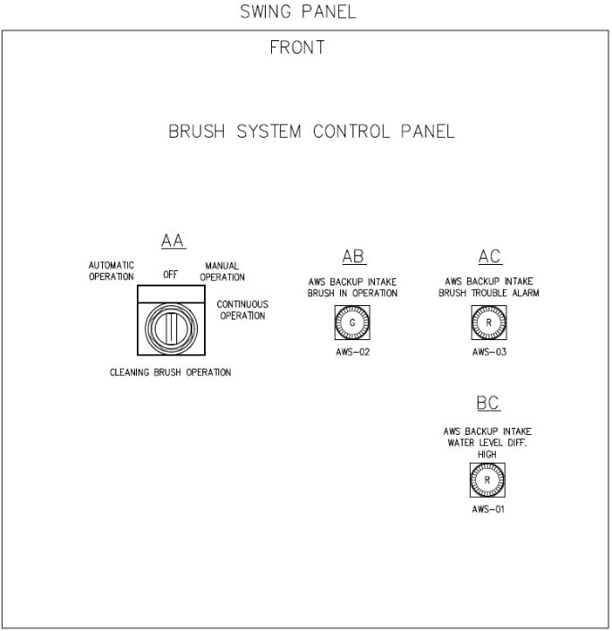
Figure 14- Brush System Control Panel Layout (Conceptual – Final Design Provided by Manufacturer)

Design Methods

480VAC Power Distribution
Electrical power supply is required for the new rotating brush & Brush System Control Panel (32.4A). An electrical capacity analysis was conducted by Stantec using SKM Power Tools and it was determined that the new rotating brush & Brush System Control Panel supply can be derived from the existing Dalles Dam electrical system via MCC FCQ7 compartment 1D. Refer to 8.4 Design Calculations.

Raceway Routing
Preliminary routing of new raceway is as follows: New conduit shall be installed from existing aluminum junction box located above MCC FCQ7 to a new pullbox located outside the service gallery doors. From there, new conduit shall be installed along the downstream side of the dam toward the east roadway. New conduit will continue across the existing asphalt roadway via new electrical ductbank to reach the upstream side of the dam. New conduit will continue along the upstream side of the dam toward the intake forebay deck where the new Brush System Control Panel will be installed. Additionally, new control conduit will be installed from existing East Exit Fish SCADA PLC to existing aluminum junction box located above MCC FCQ7.

Design Calculations
A complete power load flow analysis is included in Appendix E, and is summarized as follows:
Figure 15 – Load Flow Analysis

Design Recommendations
Details of the as designed features and relevant coordination points with related project scope will be summarized.

Cultural Resources
The Dalles Dam is greater than 50 years old and is, therefore, considered a historic structure and potentially eligible for the National Register of Historic Places (NRHP). USACE completed a NRHP eligibility evaluation for the Dam in 2015 and determined that it meets multiple NRHP criteria for evaluation regarding the property’s age, integrity, and historic significance, though it has not yet been listed. Because of its age and eligibility status, modification to the structure of The Dalles Dam, including AWS Backup system debris management structures, requires evaluation to confirm protection of significant cultural and historic resources under the National Historic Preservation Act (NHPA) and other related cultural/historic resources protection laws and regulations. To comply with NHPA requirements, Washington Department of Archaeology and Historic Preservation (DAHP), Oregon State Historic Preservation Office (SHPO), affected Native American Tribes/Tribal Historic Preservation Offices (THPOs) and other interested parties were consulted.
USACE determined that the proposed work meets the definition of an ‘undertaking’ as defined by 36 CFR 800.16(y) under the NHPA. In consultation with USACE's Seattle District Technical Center of Expertise, Preservation of Historic Buildings and Structures (NWS-TCX), it was previously determined that to work will be (USACE 2019):
- will be relatively small-scale;
- the resulting AWS feature will cause minimal visual intrusion beneath the existing fish ladder arcade;
- the AWS installation will not require the removal of any significant contributing components or aspects of the powerhouse and EFL;
- the additional deficiencies and maintenance needs that have been identified and proposed as “follow-on work” to the 2016 AWS construction effort will similarly be relatively small-scale, cause minimal to no visual intrusion and will not require the alteration or removal of any historically significant contributing components or aspects of The Dalles Dam; and
- although retrofitting of the AWS will take place in the Dalles Dam non-overflow monolith, the relatively small scale and low visibility of the new feature (much of which will be placed underground beneath the existing pavement level) will not pose a visual intrusion to the essential design and operational qualities of The Dalles Dam that were present during the historic period (1957-1973). In accordance with 36 CFR 800.5[b], the Corps has determined the proposed on-dam actions will have No Adverse Effect on The Dalles Dam and will not adversely affect the property's NRHP eligibility.

USACE reviewed previous cultural assessments and surveys for cultural resources and historic properties in the immediate vicinity and determined that no cultural resources or historic properties are likely present within the proposed area of potential effect (APE). The Dalles Dam occurs within the vicinity of culturally significant areas important to the Confederated Tribes and Bands of the Yakama Nation (Yakama), Confederated Tribes of the Warm Springs Reservation of Oregon (CTWSRO), Confederated Tribes of the Umatilla Indian Reservation (CTUIR) and Nez Perce Tribe (Nez Perce), but USACE has determined that no locations where significant cultural or traditional practices have occurred or may occur will be affected by the proposed activities. Therefore, USCAE determined that proposed activities will have No Effect on any historic properties and/or other cultural resources, and No Effect on The Dalles Dam NRHP eligibility.
USACE notified DAHP, SHPO, Yakama, CTWSRO, CTUIR, Nez Perce, and the U.S. Forest Service – Columbia River Scenic Area of the NRHP effects determination in 2015. The following responses were received:
- DAHP responded to the determinations of effect with an official concurrence letter dated September 22, 2015
- SHPO responded with an official concurrence letter dated September 30, 2015, and deferred to the decision of DAHP regarding overall determinations of effect regarding possible effects to the historic built environment
- the Tribes and USFS declined to offer comments and/or chose to not offer comments regarding this undertaking (USCE 2019)
It is assumed that USACE will confirm with DAHP that the final design is consistent with the previous effects determination. Because the proposed structure is similar to previous evaluated alternatives and does not extend above existing structures (gantry crane) in height, it is anticipated that DAHP’s effects determination will not change.

Dam Safety
Dam safety programs aim to achieve the viability of dam structures, particularly during large flood and/or seismic events, and the functional capacity to retrain or release water safely so as to avoid undue risk to the public, environment, or property.

Design Assumptions
The improvements proposed to the AWS intake, including the mechanical brushing equipment, electrical power improvements, anchorages, instrumentation, and controls communications are isolated to augment the existing functions of the AWS Intake for the EFL system. The added equipment is negligible when compared to the mass of the eastern non-overflow dam and will have no effect on the behavior of the mass concrete gravity structures. Furthermore, as the functionality of the AWS Intake is limited to EFL operations and has no impact to the ability of the power project to pass flows through the spillway or powerhouse. The underlying dam safety of the Dalles Power project is therefore concluded to be unaffected by the proposed improvements.

Construction
The proposed telescopic trash rake system requires mounting to a horizontal galvanized steel beam for lateral functionality. The horizontal beam is structurally founded on two vertical galvanized pedestal beams, with connection plates on both ends, which are anticipated to be set on leveling plates and grout. Connection to the upper concrete surface of the trashrack gallery precast concrete is anticipated to be made through retrofitted embedded hardware, using a chemical, epoxy anchoring system with post-installed anchor rods. It is anticipated that the contractor will need to occupy sections of the dam access road directly over the AWS Backup System intake structure to enable transfer of materials and equipment to support the trashrack installation.

Environmental, Health, and Safety
The installation work for the trashrack pedestal beams will require the contractor to make appropriate planning and coordination arrangements with the facility and provide a detailed Environmental, Health, and Safety (EH&S) work safety plan that considers the following work safety planning items, and OSHA requirements.
- Personnel working at heights over water. Regardless of contractor means and methods for the execution of the installation, it remains that contractor personnel will be exposed to working at heights and over water; therefore, the contractor must provide fall protection if the distance from the walking/working surface to the water's surface is 6 feet (1.8 m) or more. Until such time the contractor means and methods are known, the following determinations apply. (Source OSHA website. Author Russel B. Swanson, Director, Directorate of Construction regarding the requirements for fall protection and U.S. Coast Guard-approved life jackets and buoyant work vests during construction activities over water. https://www.osha.gov/laws-regs/standardinterpretations/1999-09-28)
  - 29 CFR 1926.501(b)(1) states that "each employee on a walking/working surface (horizontal and vertical surface) with an unprotected side or edge which is 6 feet (1.8 m) or more above a lower level shall be protected from falling by the use of guardrail systems, safety net systems, or personal fall arrest systems." The preamble to the standard states the term "lower-level surface" includes liquids (volume 59 of the Federal Register, page 40,681). Therefore, employers must provide fall protection during construction activities when employees are working 6 feet or more above the water.
  - When fall protection is provided on walking/working surfaces located above water, and no drowning hazard exists, employees do not need to wear U.S. Coast Guard-approved life jackets or buoyant work vests. Section 1926.106(a) states that "employees working over or near water, where the danger of drowning exists, shall be provided with U.S. Coast Guard-approved life jacket or buoyant work vests." In general, when continuous fall protection is used (without exception) to prevent employees from falling into the water, the employer has effectively removed the drowning hazard, and life jackets or buoyant work vests are not needed (but see below regarding the use of nets).
  - When using Safety Nets as fall protection, U.S. Coast Guard-approved life jackets or buoyant work vests are usually required. The use of safety nets as fall protection during marine construction activities usually will not eliminate the drowning hazard. In this case there is a risk that materials heavy enough to damage the nets may fall. Therefore, the personal flotation device and the other applicable requirements of §1926.106 apply. Also, the §1926.106 requirements apply during the installation of the nets.
  - The use of fall protection, including fall protection that eliminates drowning hazards, does not relieve the contractor from having to provide ring buoys and a lifesaving skiff under §1926.106(c) and (d). The requirements in §1926.106(c) and (d) for ring buoys and a skiff address the hazard of falls that may occur in the event of a failure of the operation of fall protection devices or a lapse in their use. Therefore, ring buoys and a skiff must be provided irrespective of the fall protection provided on the marine construction site.

- Personnel working above an active or inactive AWS Backup System intake (including adoption of facility lock-out tag out procedures)
- Personnel working at or around active (energized) electrical panels and equipment
- Maintenance of traffic vs. personnel safety
- Environmental control measures (Personnel and Equipment)
- Emergency planning.

Security
The contractor’s workforce shall submit all identified workforce personnel Government issued Identification cards well in advance of the anticipated commencement date for construction activities at the facility. To avoid any potential delays to the construction program, it is anticipated that this process will begin immediately, post-contract award.
It is anticipated that most of the work shall be performed from land-based contractor operations, however, contractor safety requirements emanating from working at heights above water may require the intermittent or continuous presence of a duly manned safety/rescue boat positioned adjacent to the works for the duration of the installation program. It is unknown, at this point, what size of boat or mooring requirements the contractor-proposed rescue boat will present to daily operations and securing of the boat outside of work hours. As such, facility security personnel should consider partial daily crew attendance arriving by water and how such daily arrivals by water could be officially facilitated, including logging approved personnel at site via sign-in and out procedures.

Basic Construction Assumptions
It is assumed that the Contractor will be afforded clear access to the trashrack gallery work area, partial road occupancy of the roadway directly above the AWS intake, and an accessible material lay-down area that will be identified by the facility.
It is assumed that the Contractor will be self-sufficient and independent of facility utility needs, until final connections are made during commissioning of the M&E components of the trash rake proposed. The contractor will be expected to provide appropriate sanitation measures relative to workforce numbers, and construction debris, trash collection and disposal as required.

Construction Methodology
The physical installation of the telescopic hydraulic trash rake will require the following steps; detailed means and methods are the responsibility of, and will be provided by the supply and construction contractors:
- Confirm rake pedestal beam embedded hardware plate locations through prior assembly of units and use of templates. Transfer embedment hardware to concrete coring locations atop gallery precast through survey.
- Perform top-down concrete coring of assumed one-inch-diameter by 12-inch-deep concrete core at embedment hardware locations. Assume four locations per pedestal (and eight total). Clean and prepare concrete cores per chemical bonding manufacturer recommendations and set embedment hardware. Perform installed survey to re-affirm embedment hardware location, ensuring plumbness of embedded hardware set using epoxy or grout. Allow sufficient time for setting of embedded hardware conforming to manufacturer recommendations.
- Fit pedestal beams and the traversing beam in accordance with trashrack manufacturer guidelines. Use of levelling plate and grout will be required to ensure traversing beam is appropriately set. Allow sufficient time for leveling grout to set, prior to application of additional loads of telescopic rake unit.
- Install traversing telescopic trash rake unit to the horizontal beam. It is unknown at this juncture if the proposed unit will require additional gangways or personnel access areas behind the unit for commissioning and O&M purposes. As information becomes available regarding the installation of M&E component to the physically assembled and installed pedestal, traversing gantry beam and trashrack unit, this section will be updated.

M&E Construction requirements to support facility connectivity
Construction requirements to support I/O, power and hydraulic requirements of the unit at the facility will be identified. Connectivity runs, panel hook-ups etc. to be identified and impacts to operations anticipated should be laid out in the design.

Commissioning of trashrake
Prior to commissioning of the trash rake, a 100% visual inspection shall be made underwater to ensure that the intake remains free of material/equipment and or tooling that may have fallen through the water column during construction activities. Any debris, equipment or tooling lost during construction within 50 ft of the intake tunnel shall be removed from the water at no cost to the project, PRIOR to commencement of commissioning activities.
Commissioning of the trash rake shall be as per Manufacturers guidelines will be further expanded within the following M&E section related to the trash rake.

Operations and Maintenance
This section will be developed during the design process to capture operations and maintenance criteria which may be relevant to the design criteria of individual components.

Design Assumptions
Assumptions pertaining to the operational procedures of the equipment and preventive/corrective maintenance programs will be listed as the project design develops.

Safety
Operator safety considerations will be developed and incorporated in the design.

Security
Data security considerations will be developed and incorporated into the design.

Operations
Operations criteria will be developed and incorporated into the design.

Maintenance
Maintenance criteria will be developed and incorporated into the design.

Cost and Value
Note: This section will be completed by USACE staff.

Design Assumptions
Body text.

Design Criteria
Body text.

Design Methods
Body text.

Design Calculations
Body text.

Analysis Results
Body text.

Design Decisions
Body text.

Design Recommendations
Body text.

Conclusions and Recommendations

Conclusions
Note: Conclusions to be presented later in the DDR development process.

Recommendations (J&A Justification)
The preferred alternative, outlined in the EDR was a mechanically rotated brush to be operated by cable winches on the deck of the intake; however, during the initial design it was determined that a telescoping boom operated rotating brush would have greater cleaning performance and ease of operation given the unique layout of the intake and operational situations encountered by the equipment. The intake is unique in that utilizes vertically orientated trashrack screens, is exceptionally high from screen invert to the operations deck (80ft), has a small operations deck, and utilizes standard bar grating which results in a non-uniform profile of the panels.
Stantec researched systems from existing suppliers which could be adapted for use on the project, rather than develop prototype equipment for the stated design criteria. During inquiries to suppliers who typically manufacture intake cleaning equipment for the hydropower or municipal sectors, Stantec reviewed the project requirements and discussed the system offerings of potentially suitable winch operated or telescoping boom operated brushing products of equipment suppliers, who noted the following design challenges:

- The winches identified in the EDR, will have to full fledge hoists with suitable holding brake and control brake, and electrical controller as the weight of the hydraulically/electrically motor operated cleaning head will be substantial. Thus, provision of hoists and installing that in a limited space at the deck, will be costly proposition. As the rotating brush will be lifted with at least two points, synchronized operation of the two lifting points can be adequately addressed by the twin drum hoist and suitable reeving system.
- Guiding the cleaning head through a travel length of over 70 feet during cleaning process may be a challenge, especially in winter when guide slots are frozen or blocked with ice, thus requiring a positive downward push to the cleaning head. Regular hoists/winches will not be able to provide such downward push, thus requiring cleaning head to be made as heavy as possible. Providing guide slots in concrete with suitable stainless steel embedded parts & their alignment is substantial work.
- Rotating brush will either require a submersible electrical motor or a hydraulic motor to rotate the cleaning brush. To provide protection and a safe connection for such self-winding hydraulic hoses or electrical cables (with submersible electrical connections) from the deck is quite challenging, especially due to the depth (80 feet) and providing protection to dangling hoses/cables from floating debris during cleaning operation is a challenge.
- It was considered that a positive pressure may be required in the direction of trashrack intake flow, so as to maneuver or push the cleaning head against the rack bars to help in cleaning the debris. This will be hard to achieve with a winch or hoist layout, where cleaning head is just moving up & down, in embedded guided surfaces.
- Most of the manufacturers took exception to the uneven surface profile of the trashrack panels, where structural members are protruding out from the rack surface by over 2”.
Atlas Polar was the only manufacturer that was confidant in the performance of their equipment (model DT9300) in accordance with the criteria developed. Atlas Polar has qualifying experience in manufacturing machines which address the project criteria, which has following positive features:
- This machine has a telescopic boom which can traverse up & down for full depth of 80 feet, thus no special guides are required in the bay concrete wall with stainless steel embedded parts.
- The machine can provide a push or positive pressure against the rack bars during cleaning, if needed to remove jammed or clogged debris.
- Cleaning in the deep water under dynamic condition is generally considered tough; this machine has good experience in raking at considerable depths even under flowing water condition.
- Unlike hoist/winch, this rake machine can generate positive thrust while telescopic boom is moving up or down during cleaning.
- The machine has hydraulic motor at rake head for rotating the cleaning brush-as envisioned in EDR; all hydraulic hoses are well protected from floating debris during cleaning.
- Machine had PLC controller, which allows it to do indexing during raking operation, thus whole cleaning operation can be programmed for automatic operation.

References
Note: This section to be populated in later stages of the DDR development with references per the structure outlined in the USACE-supplied example DDR as GFI in the procurement stage of the project..

The minimum tailwater 76.4 feet as shown above is based on an approximate median Bonneville Forebay of 74 feet NGVD 29 and a river flow of 100,000 cfs. Both values do go lower and the minimum tailwater elevation recorded between 1990 – 2021 was 71.6 feet.
Flow-3D, Flow Science, Inc. Santa Fe, NM, 2022.
USACE Bathymetry Survey, 1999.

